
Seasons on Earth
ICT Task 4

Learning Intention:

Success Criteria:

Task 1.
Using Seasons, explore the Earth’s orbit, day and night, factors causing variation in the Sun’s heating effect and the seasons.

Use this link to access Seasons: http://ecm.det.wa.edu.au/connect/resolver/view/L5774/latest/L5774/index.html#

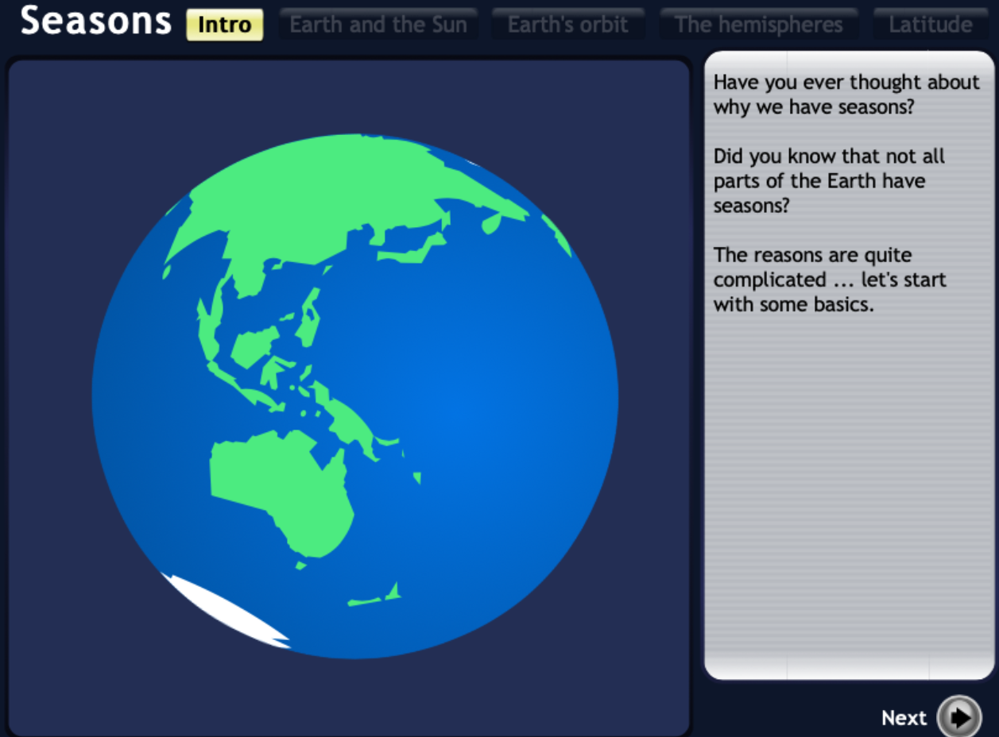

- Explore how the Earth orbits the Sun and how the rotation of the earth makes the Sun appear to move across the sky.

- Go through all the activities at the top to find out more.

Task 2
Construct an electronic presentation (e.g. PowerPoint) on the how the seasons happen.

Utilise the shape drawing tools on Microsoft PowerPoint.

If you are unsure about how to use the shape drawing tools on Microsoft PowerPoint go to the following link: https://www.lifewire.com/how-to-draw-in-powerpoint-4691715

Task 3
Not everyone experiences summer, autumn, winter and spring. For example, people in the far north of Australian instead talk about the wet and dry seasons. Research the seasons used by Aboriginal and Torres Strait Islander peoples.

